RAIL-INVEST

System for Investment Decision Support in Yugoslav Railway

A complex methodological analysis of impacts of financial and economic factors on investment decision making, as well as big capital investments in railway traffic, emphasize the importance of implementing a software system RAIL-INVEST that will allow precise and reliable planning of investments in this field. It has been implemented according to the Methodology for Financial and Economic Analysis and Appraisal of Investment Projects in Yugoslav Railway Traffic.

Features

RAIL-INVEST is aimed at evaluating the investment projects in railway traffic. From the methodological point of view, it consists of financial and economic analysis and appraisal of investment projects in railway traffic. Financial and economic appraisal are based on the COST-BENEFIT method.

RAIL-INVEST provides:

- Financial analysis: Investments and avoided investments in infrastructure objects and transportation means, incomes based on gained second hand materials, transportation costs, income from transportation services, the remainder value of investments and avoided investments are of concern in economic analysis.

- Financial appraisal: Financial appraisal, i.e. appraisal from the railway standpoint, uses different methods and criteria or their combinations. RAIL-INVEST supports the following methods:
  - net present value method
  - relative net present value method
  - internal rate of rentability method
In order to minimize forecasting errors, sensitivity analysis is applied within project appraisal. In RAIL-INVEST's project sensitivity analysis, a rentability threshold method, which includes project effects dynamics throughout the entire project life cycle, is applied.

- Economic analysis: Investments in infrastructure objects and transportation means, avoided investments in railway and road traffic, transportation costs in railway and road traffic, transportation prices, duration of traveling, energy costs, protection of natural environment, the remainder value of investments and avoided investments are of concern in s/e analysis.

- Economic appraisal:
Economic appraisal, i.e. appraisal from the s/e standpoint, supports the following methods:
  - economic net present value method
  - relative economic net present value method
  - economic internal rate of rentability method
Economic appraisal also includes project sensitivity analysis.

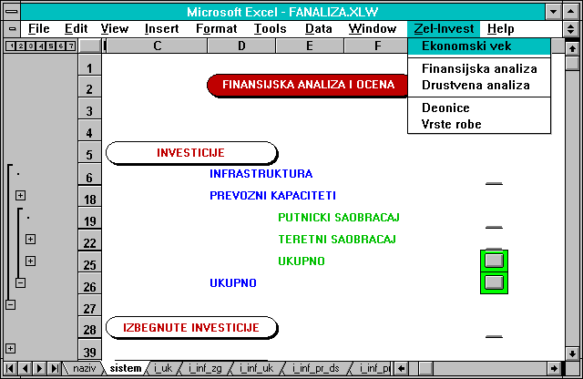

Menu for the financial analysis

Technical information

RAIL-INVEST is implemented using MS Excel. The application runs on MS Windows.

