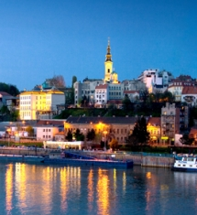
Workshop Chair
Chair: A. Rodić, Institute Mihailo Pupin, Serbia
Co-chair: D. Katić, Institute Mihailo Pupin, Serbia
International Scientific Committee
K.Schilling,Julius-Maximilians-University Wuerzburg Am Hubland, Germany
A. Wagner, Heidelberg University, Germany
K. Berns, University of Kaiserslautern, Germany
C. Chevallereau, Institut de Recherche en Communications et Cybernetique de Nantes, France
Đ. Mešter, University of Szeged, Hungary
M. Ceccarelli, University of Cassino and South Latium, Italy
G. Gini, Politecnico di Milano, Italy
F. Amigoni, Politecnico di Milano, Italy
Y. Nakamura, University of Tokyo, Japan
R. Ventura, Institute for Systems and Robotics
Instituto Superior Técnico, Portugal
D. Pisla, T U Cluj-Napoca, Romania
V. Golovin, Moscow State University, Russia
B. Nemec, Jozef Stefan Institute, Slovenia
A. Ijspreet, EPFL, Switzerland
H. Huosheng, University of Essex, UK
S. Cameron, Oxford University, UK
V. Potkonjak, University of Belgrade, Serbia
D. Popović , University of Belgrade, Serbia
B. Borovac, University of Novi Sad, Serbia
Advisory Board
H. Bleuler, EPFL, Switzerland
D. Pisla, Technical University of Cluj-Napoca, Romania
S. Vraneš, Institute Mihailo Pupin, Serbia
Author’s schedule:
Submission of abstracts, May, 31st , 2013
Power Point presentations
and video, June, 20th, 2013
Registration Fees:
Free of charge for the invited speakers
250 Euros other

Contact mail:
aleksandar.rodic@pupin.rs

Workshop web-site:
www.pupin.rs/RnDProfile/events.html

Call for presentations
The 2nd International Exploratory Workshop on new trends in medical and service robotics will be held in the Mihailo Pupin Institute, Belgrade, Serbia. The workshop is envisaged to bring together in a collegial and stimulating atmosphere invited reputed speakers dealing with multi-disciplinary aspects of medical and service robotics and applications. In accordance with the objectives, the MESROB 2013 will cover the main areas of robotics research, medical and service robotics and applications, etc.

Workshop Topics
Presentations are focused on topics related to one of the following general and particular areas of interest but not limited to:
- Robot kinematics and dynamics
- Parallel robots and mechanisms
- Design, modeling, system identification and simulation
- Bio-inspired robotics and bio-mimetic systems
- Medical robots, active prosthesis and exosceletons
- Remote diagnosis and surgery
- Elderly assistive robots
- Service robots (indoor and outdoor)
- Robotic vision and sensing
- Navigation, motion planning and control
- Cognitive robotics
- Social and behavioral robotics
- Robot learning and intelligent handling
- Dual-arm systems, anthropomorphic hands, manipulation
- Human-robot interfaces, etc.

Submission of presentations and proceedings
The working language of the workshop is English. The participants will receive a copy of the proceedings and video material on an e-key and a printed book of abstracts and workshop program. Authors of the presentations will be invited after the workshop to submit the papers (related to the presentations) for publishing in the Springer monograph series “Mechanisms and Machine Science”.

Venue
The workshop will be held in the Mihailo Pupin Institute, Belgrade, (http://www.pupin.rs/en/), Serbia. Majority of European airports have daily flights to Belgrade. Belgrade is a city on the Danube river http://www.beograd.rs/cms/view.php?id=220 , one of the most popular tourist destinations. It offers high range hotel accommodation, delicious cousin, attractive restaurants on the Danube riverside with live music and fun, etc.
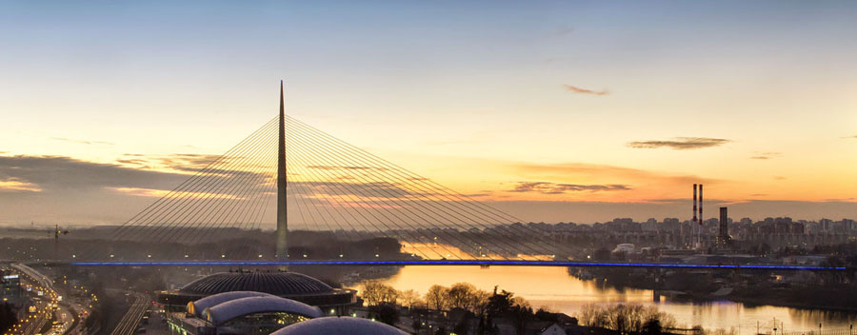

Social program
Participants and accompanying persons will enjoy rich social program organized in three days:
1st day: Banquet organized in one of the ethno-restaurants (http://www.starakoliba.rs/home.html) with live music,
2nd day: Belgrade panoramic tour,
3rd day: Excursion to the “Mokra Gora” (http://www.parkprirodemokragora.org/index.php?l=16) the park-of-nature situated in the middle-west mountain region of Serbia; Visit to the ethno-village “Drven grad”; Short excursion “Shargan 8” by the old-fashion steam-engine train; Lunch in the nature.
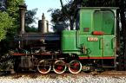
Park of nature “Mokra Gora” and old-fashion train “Shargan 8”

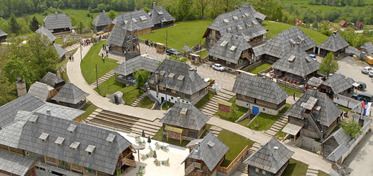
The UNESCO project - Wooden ethno village “Drven-grad”

Coordinator: Prof. Dr.-Ing. Aleksandar Rodić
Organizing committee: Dr.-Ing. Miloš Jovanović, Marija Tomić, Sofija Spasojević,
Branko Miloradović, Ilija Stevanović

This work is supported by SNSF (Swiss National Science Foundation) through the SCOPES program, project number IZ74Z0_13761/1.

This work is supported by Serbian Ministry for Education, Science and Technology through the projects TR-35003 and III-44008.

May, 2013

